Alexander Rodriguez

Wrangle Data using WeRateDogs

**The twitter account WeRateDogs is collection of dog pictures with a dog rating and a comment about the dog’s appearance. Posts are from dog lovers who use the platform to showcase their beloved dogs doing cute things or in adorable poses. Let’s take a closer look.**

First we start with some examples of a picture of the dog with the highest favorite count, the highest rated dog, and the lowest rated dog.

1. The dog with the highest favorite and retweet count.

|  |  |  |  |
| --- | --- | --- | --- |
| **Rating** | **Text** | **Favorite Count** | **Retweet Count** |
| 13/10 | This is Stephan. He just wants to help.  13/10 such a good boy | 123880 | 61884 |



1. The Dog with the highest rating. It turns out that his rating is in honor of Independence day. What a cute dog!

|  |  |  |  |
| --- | --- | --- | --- |
| **Rating** | **Text** | **Favorite Count** | **Retweet Count** |
| 1776/10 | This is Atticus.  He's quite simply  America af. 1776/10 | 5557 | 2739 |



1. I wonder what the motivation was behind this? Perhaps since the picture was tweeted on November 16, 2015 it is in preparation for Thanksgiving.

|  |  |  |  |
| --- | --- | --- | --- |
| Rating | Text | Favorite Count | Retweet Count |
| 1/10 | Not familiar with  this breed. No tail (weird). Only 2  legs. Doesn't bark. Surprisingly quick. Shits eggs. 1/10 | 14557 | 6751 |

**Now we are going to look at the top three most popular breeds.**

It is interesting to find out what are the most popular dog breeds that are posted onto the WeRateDogs twitter group. The top 5 are the following:

1. Golden Retiever
2. Pembroke
3. Labrador Retriever
4. Chiuahua
5. Pug

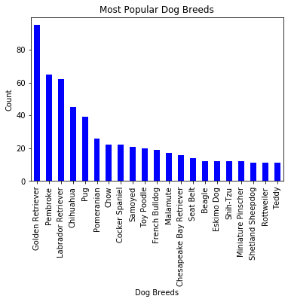****

Picture of the top 2 breeds on

WeRateDogs (Golden Retriever and Pembroke).

**What are the most popular dog names? Looks like Oliver, Tucker and Winston are the most popular names.**

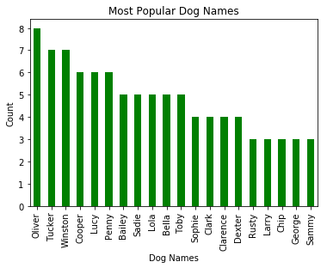

Picture of Oliver. Looks to be a mischievous one.

**When are the Favorite Counts the highest?**

It is a bit difficult to tell when the counts go high (above 79,000), but there are spikes in December, January, May and June.

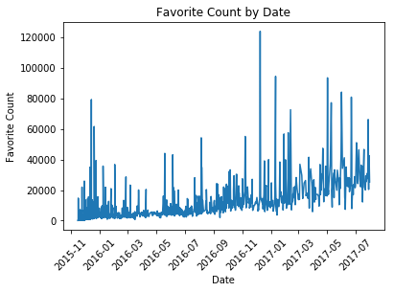



This is Bo, a Poodle with 94,385 favorite count. The tweet date is 1/11/2017.

As evident by the beautiful pictures and the accompanying text and rating.